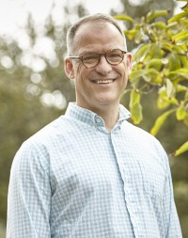 | Dave Mochel  Author, Coach, CEO of Applied Attention, Expert on The Science and Practice of Mindfulness, Well-being, Leadership, and Culture

Dave is a one-man retreat. He uses compelling stories, research, and humor to create a captivating environment and experience that is dynamic, inspiring, and highly relatable. As the foremost expert in the revolutionary approach of mindful self-regulation, Dave illuminates the incredible human capacity for unconditional wellbeing – the ability to thrive and grow independent of circumstances. Moreover, he shows how we can leverage this capacity with simple daily practices that foster peaceful and powerful lives, relationships, and cultures.
Dave draws on his experience as a two-time cancer survivor, and more than thirty years of studying and teaching the practices and principles of mindfulness, well-being, and leadership, He combines modern science, enduring wisdom, and practical application in a way that is engaging, interactive, and transformative.
As the founder and CEO of Applied Attention Coaching and Consulting, Dave works internationally with individuals, teams, and leaders to help them focus their attention and energy where it will make the greatest positive difference. He gives people the tools they need to:
- Work peacefully and powerfully with stress, anxiety, distraction, and setback.
- Strengthen relationships through clear, kind, assertive communication.
- Turn challenges and resistance into opportunities by cultivating positive internal resources and focusing on what is most important
Dave has coached new and established leaders as well as championship athletes, health care professionals, educators, and entertainers. He has helped start an international leadership academy that serves students from more than sixty countries. He has served as a lecturer in The Purpose Journey at Stanford University, and he is an advisor to The Wayfinder Project and Balance Position.

